**Josephine Quagraine**

Data Manchester cohort 5 | 4th April 2023

**ASSIGNMENT 1**

**Data visualization using Microsoft Excel and Tableau**

Contents

**Table of figures** 2

**Chapter 1** 3

1.1 Data Policies and Procedures 3

1.2 GDP tasks in Microsoft Excel 4

1.2.1 Set password to protect workbook 4

1.2.2 Highlight column C & add British pound (£) 5

1.2.3 Turn GDP sheet into a table 6

1.2.4 Filter the table to display only information for 2019 6

1.2.5 Create a chart to display only the data ‘Rank, Country and GDP 7

1.2.6 Edit chart using creative skills 7

1.2.6.1 Add title 7

1.2.6.2 Add X and Y axis labels 8

1.2.6.3 Make chart visually pleasing 8

1.2.7 Move to new sheet and label 9

1.2.8 Create sort for top 20 highest ranking countries 9

1.2.9 Chart showing top 20 highest ranking countries under table 10

1.2.10 Colour background area underneath chart 10

1.3 Macro task 11

1.3.1 Create copy, save and print macros in Excel 11

1.3.2 Using the copy macro, copy sheet and save in new word document keeping formatting 12

1.3.2.1 Add title to word page 12

1.3.2.2 Save work in word 12

1.3.2.3 Add header and footer to excel table 13

1.3.2.3.1 In header, add name, GLA DATA 1 13

1.3.2.3.2 In footer, add date, assignment 1 and data visualisation 13

1.3.2.4 Return to normal view 13

1.4 Tableau 15

# **Table of figures**

Figure 1 Diagram of password box in workbook after clicking protect workbook icon 4

Figure 2 Diagram showing password has been entered to protect workbook 4

Figure 3 Figure showing column C highlighted 5

Figure 4 Figure displaying the £ sign in column C once activated 5

Figure 5 Figure showing table on GDP worksheet 6

Figure 6 Figure of GDP sheet displaying information for only 2019 after application of filter 6

Figure 7 Diagram displaying a chart with data from rank, country and GDP 7

Figure 8 Diagram showing title of generated chart using selected rank, country and GDP data 7

Figure 9 Diagram showing labelled X and Y axes 8

Figure 10 Diagram showing final formatted chart 8

Figure 11 Figure showing chart moved to new sheet and labelled accordingly 9

Figure 12 Figure showing the sort for top 20 highest ranking countries 9

Figure 13 Figure showing new bar chart under sorted table 10

Figure 14 Figure showing coloured chart background 10

Figure 15 Screenshot of created macros 11

Figure 16 Diagram of created Word document from excel workbook after copying with copy macro 12

Figure 17 Figure of saved Word document 12

Figure 18 Screenshot showing addition of header to excel table 13

Figure 19 Screenshot showing addition of footer to excel table 13

Figure 20 Figure showing normal view 14

Figure 21 Figure showing workbook saved as excel gross domestic product report 1 14

Figure 22 Diagram of generated Tableau dashboard 15

# **Chapter 1**

## Data Policies and Procedures

In the United Kingdom, the main legislation governing data protection is the Data Protection Act (DPA) 2018 which is a replacement of the DPA 1998. This act was amended on 1st January 2021 by regulations under the European Union (Withdrawal) Act 2018 to reflect the UK’s status outside the EU. The DPA is used alongside the UK GDPR which reflects the GDPR of the European Union and sets out the key principles, rights and obligations for most processing of personal data held in computerised formats as a database or manual records forming part of a relevant filing system in the UK.

The law ensures that people have the right to access information held about them and that better management is in place to prevent misuse of data. In essence, organisations need to ensure that personal data is used fairly, lawfully and transparently and used for the specified purposes explicitly. It should be used only where necessary, be accurate and be kept up to date and no longer than necessary. Above all, all data must be handled in a secure way and protected against unlawful or unauthorised processing, access, loss or damage.

As data analysts, we deal with data collection, verification, cleaning and storage. Hence knowing these data policies helps to better secure and protect the data to ensure that you are compliant and not in breach which could potentially result in a hefty fine. For example, to protect sensitive data or data subjects and yourself in the event of a breach, data analysts now use anonymisation or pseudonymisation of data. This can also help in the event of a breach as less personally identifiable information will be seen. Also the use of passwords and secure storage systems is key to ensure that you have abided by the DPA or GDPR regulations.

With regards to using the Wealth of Nations data, it is my responsibility to keep the data secure while analysing it as it relates to the economies of nations worldwide.

## GDP tasks in Microsoft Excel

### Set password to protect workbook

After downloading the workbook and saving, clicked on the **Protect Workbook** under the **Review** tab which brought up the **Password box**. Typed in my password and verified it by retyping the password again. I then clicked **OK** and clicked on the **Save** button to complete workbook protection. Setting a password to the workbook helps to protect the structure of the Excel workbook and prevents other users from viewing hidden worksheets, adding, moving, deleting or hiding worksheets as well as renaming them.

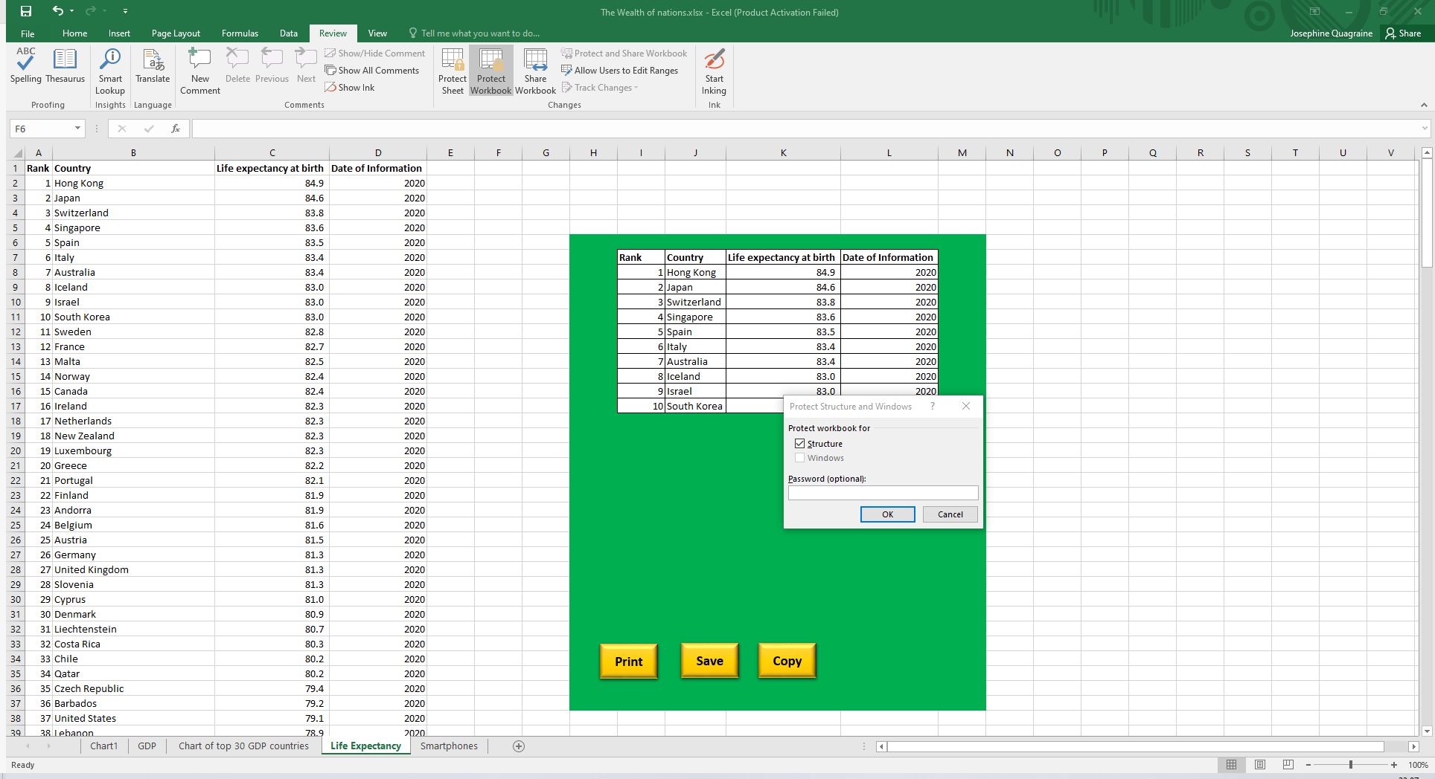

Figure Diagram of password box in workbook after clicking protect workbook icon

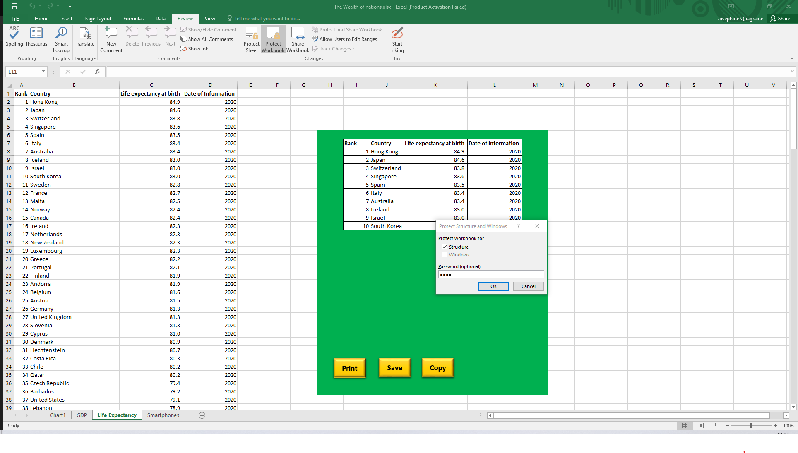

Figure Diagram showing password has been entered to protect workbook

### Highlight column C & add British pound (£)

To highlight column C on the GDP worksheet, I dragged my mouse to the column and clicked once to select the column. On the **Home** tab, I used the drop-down button on the **Number Format** pane and selected currency (**£)** which then displayed the British pound symbol.

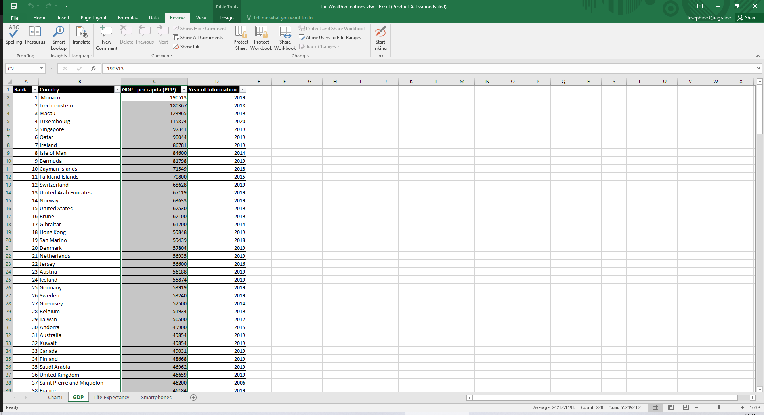

Figure Figure showing column C highlighted

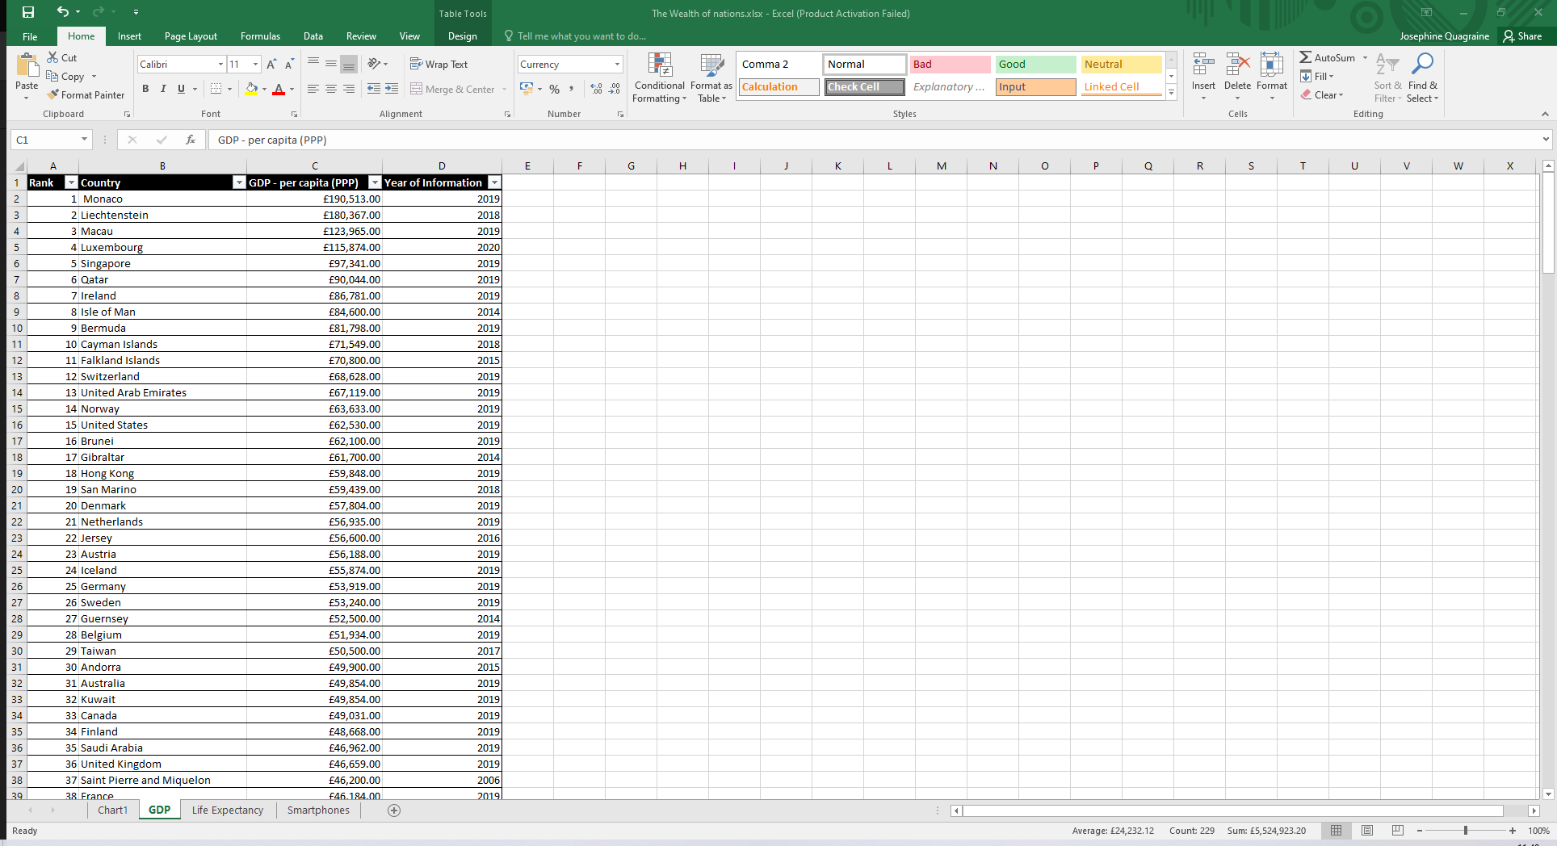

Figure Figure displaying the £ sign in column C once activated

### Turn GDP sheet into a table

Highlighted the cells that contained data and clicked on the **Insert** tab. However, the Tables group was greyed out suggesting that the data was already a table. I then clicked on the **Design (table tools)** icon and chose a table style that I liked as indicated below in Figure 7.

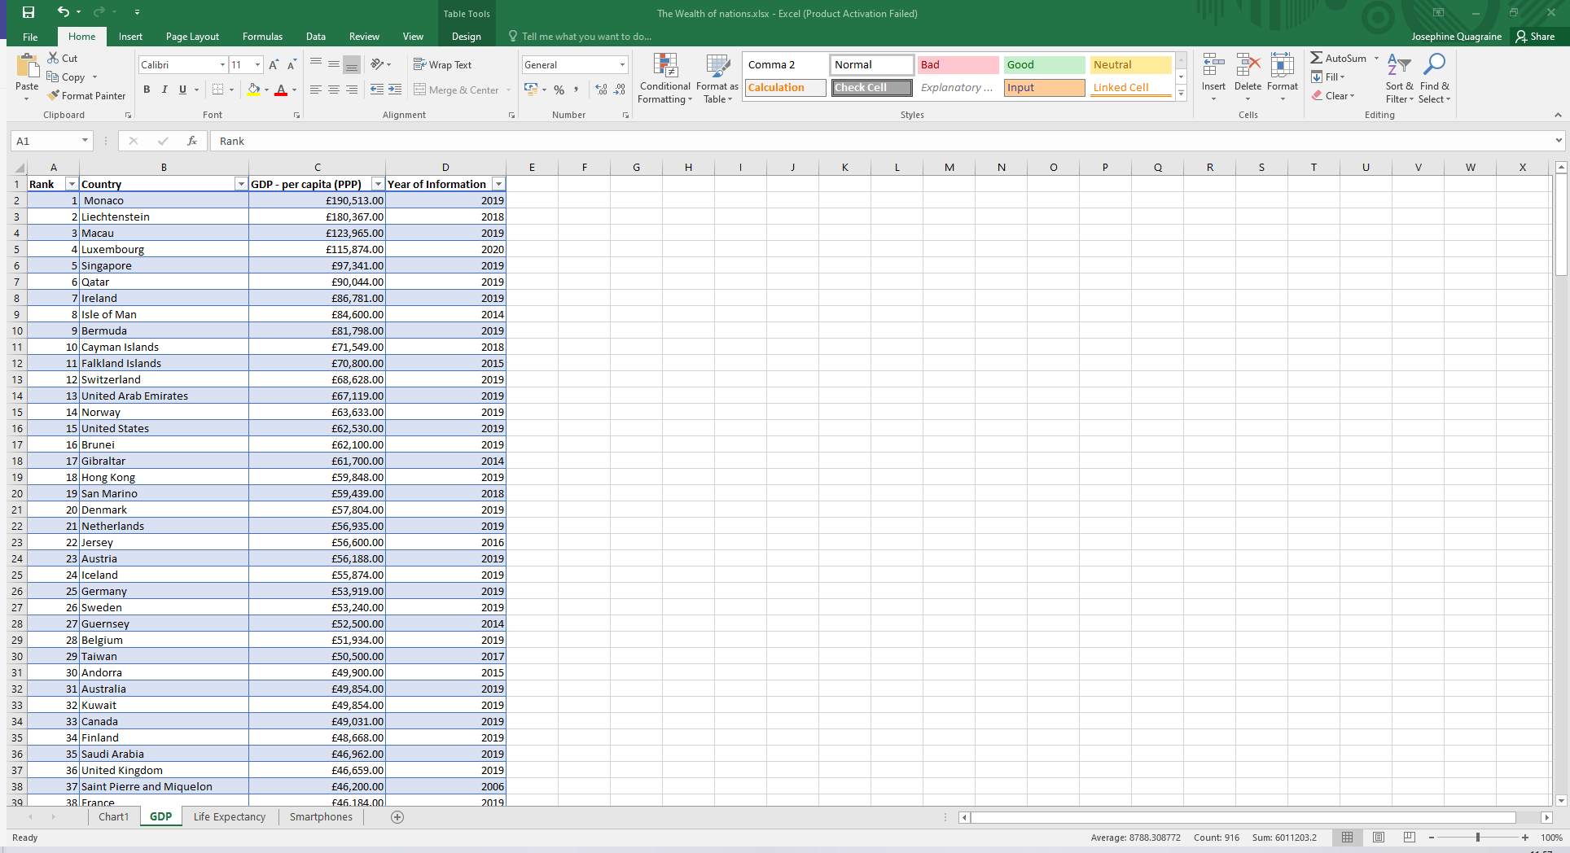

Figure Figure showing table on GDP worksheet

### Filter the table to display only information for 2019

In column D (year of information), I clicked the **drop-down button** on the right side to filter the years. I unchecked **select all** and then selected ‘**2019’** and clicked on OK. This action filtered the table to display only 2019 data as shown below.

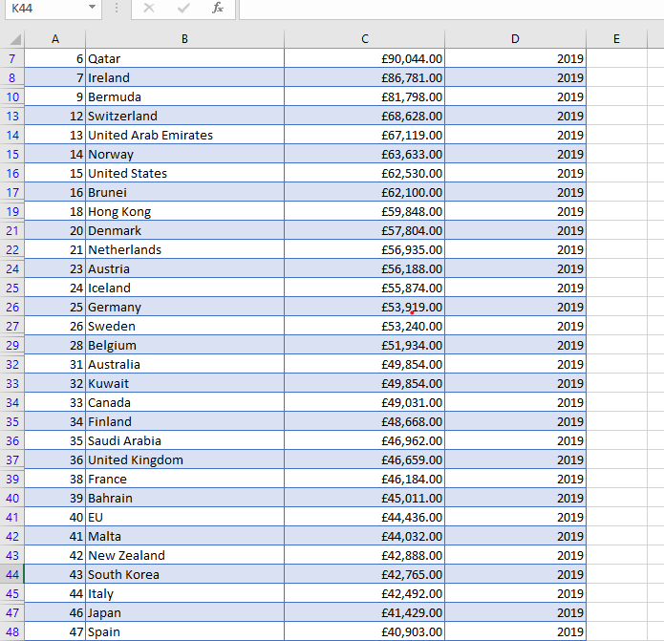

Figure Figure of GDP sheet displaying information for only 2019 after application of filter

### Create a chart to display only the data ‘Rank, Country and GDP

Decided to use the first 28 countries with high GDP –per capita to make a chart as using all the data made the chart not visually appealing. Highlighted the cells that had the data I required (rank, country and GDP) and clicked on the **Insert** tab. I selected the **2-D Bar chart** and then customized it to the way I wanted it as displayed below.

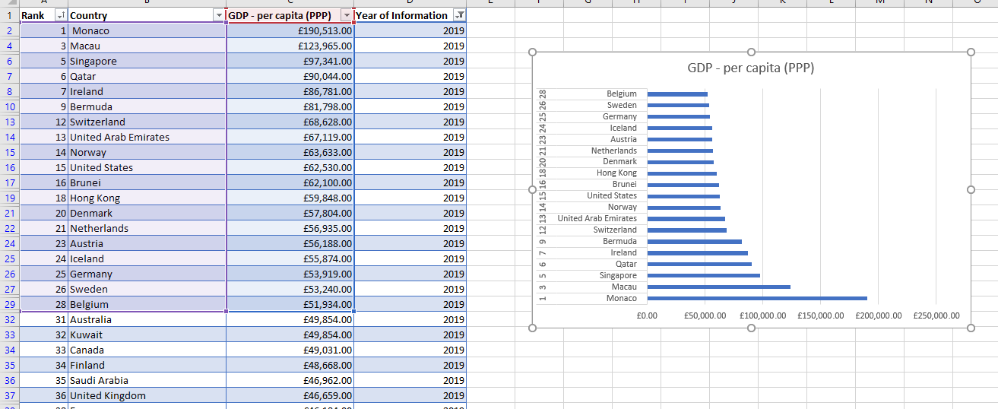

Figure Diagram displaying a chart with data from rank, country and GDP

### Edit chart using creative skills

#### Add title

My selected chart already generated a title. As such, I double clicked on the title and amended it accordingly as shown below.

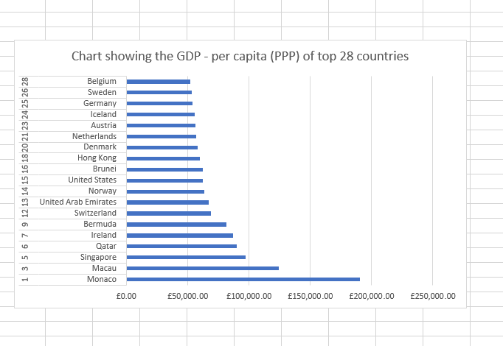

Figure Diagram showing title of generated chart using selected rank, country and GDP data

#### Add X and Y axis labels

To add axis title, I selected the **Plot area** of my chart and dragged it to downsize/ minimize it so that I can have space for my axis labels in the **Chart area**. Next, I clicked on the **Chart element** sign (+) and selected the axis labels. I then wrote my axis and amended accordingly.

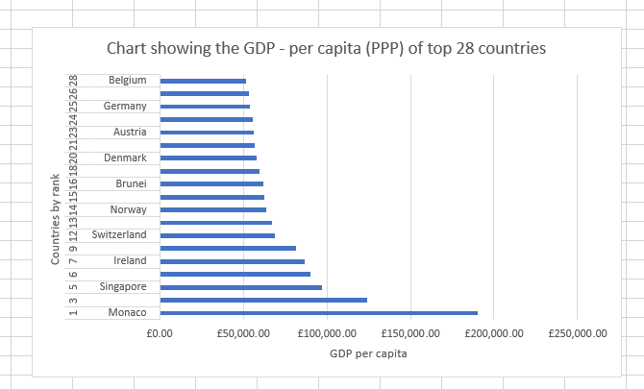

Figure Diagram showing labelled X and Y axes

#### Make chart visually pleasing

To format my chart, I selected it and then clicked on **Chart Tools Design**. I then selected the one I found pleasing to me. I also used the Chart elements to add a legend and data labels. I unchecked the gridlines to remove them from my chart as shown below.

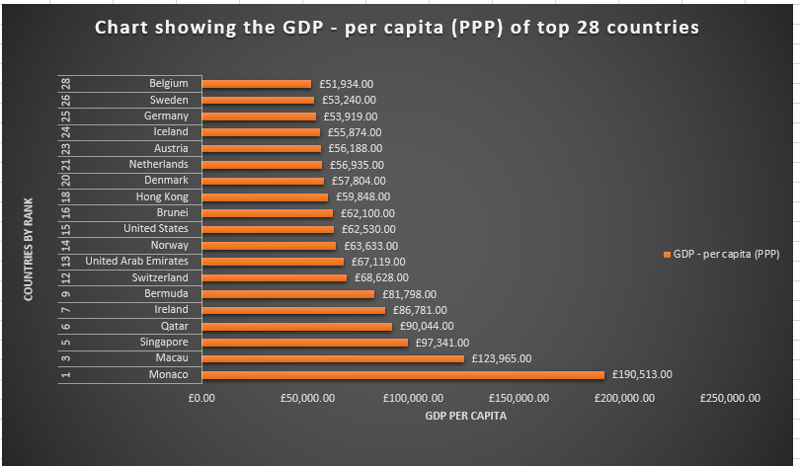

Figure Diagram showing final formatted chart

### Move to new sheet and label

To move chart to a new worksheet, I selected the chart, right-clicked and selected **Cut** from the drop-down menu. I then opened a new worksheet and **Pasted** my chart there. To label the new sheet, I double-clicked the tab which showed **‘Sheet 1’**. This enabled me to name my sheet accordingly.

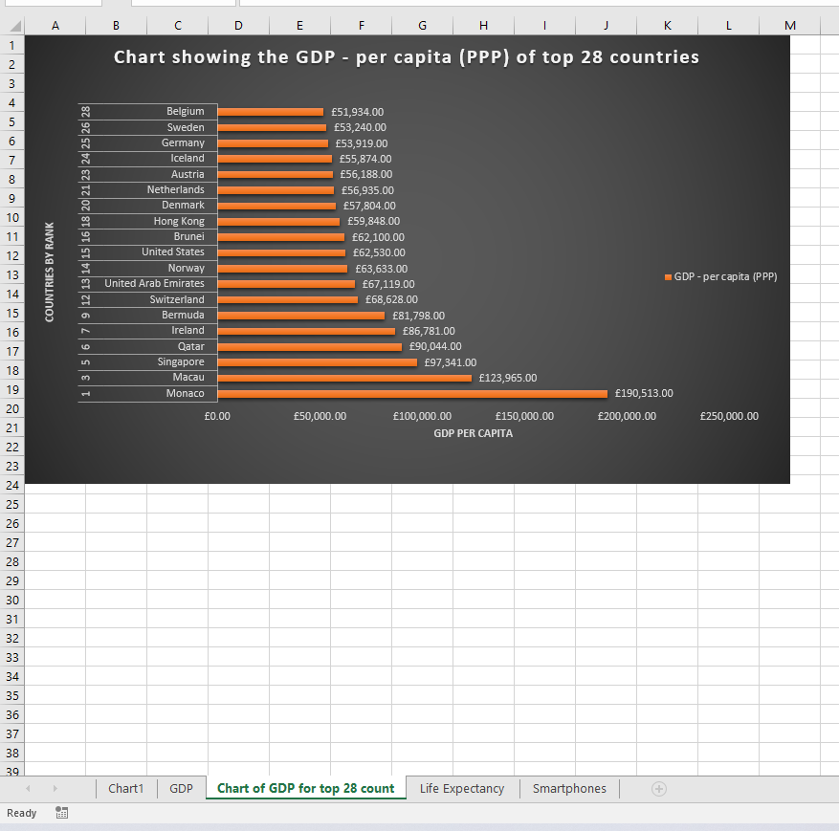

Figure Figure showing chart moved to new sheet and labelled accordingly

### Create sort for top 20 highest ranking countries

To create sort for top 20, used the filter icon in column A and unchecked select all. Then manually selected all the available ranks in the top 20 and clicked ok. This created the sort successfully.

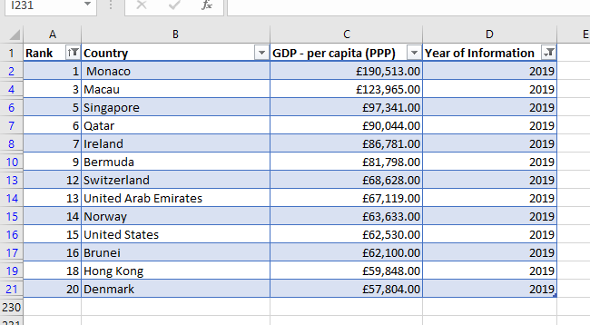

Figure Figure showing the sort for top 20 highest ranking countries

### Chart showing top 20 highest ranking countries under table

Selected rank, country and GDP and clicked on the **Insert** tab where I selected the **2-D Clustered Bar** **Chart icon** to generate a new bar chart. I then **dragged** the chart underneath my table as shown below.

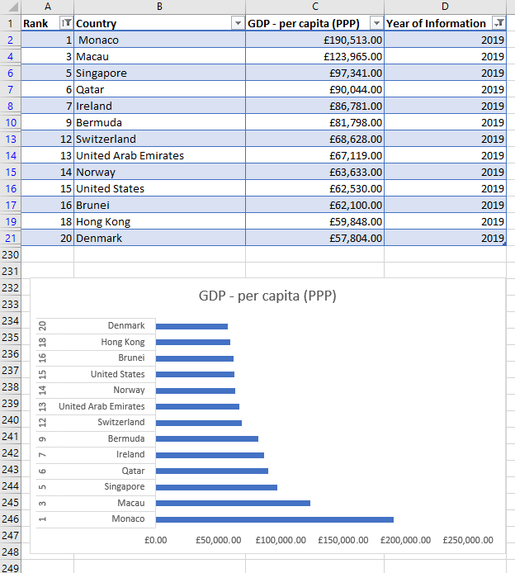

Figure Figure showing new bar chart under sorted table

### Colour background area underneath chart

To colour chart background, highlighted only the area underneath the table and on the home tab, selected the fill colour icon and coloured it accordingly.

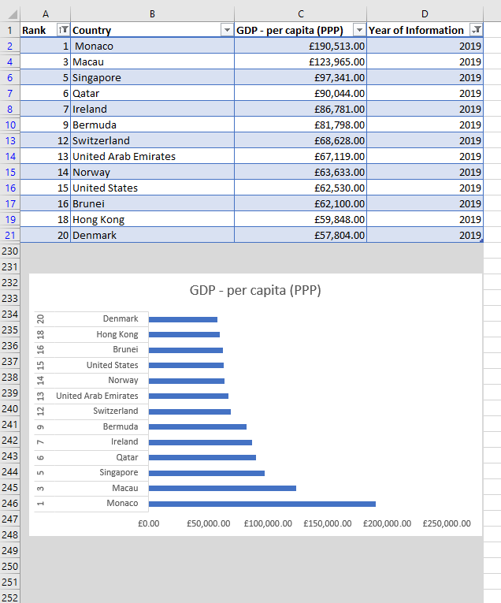

Figure Figure showing coloured chart background

## Macro task

### Create copy, save and print macros in Excel

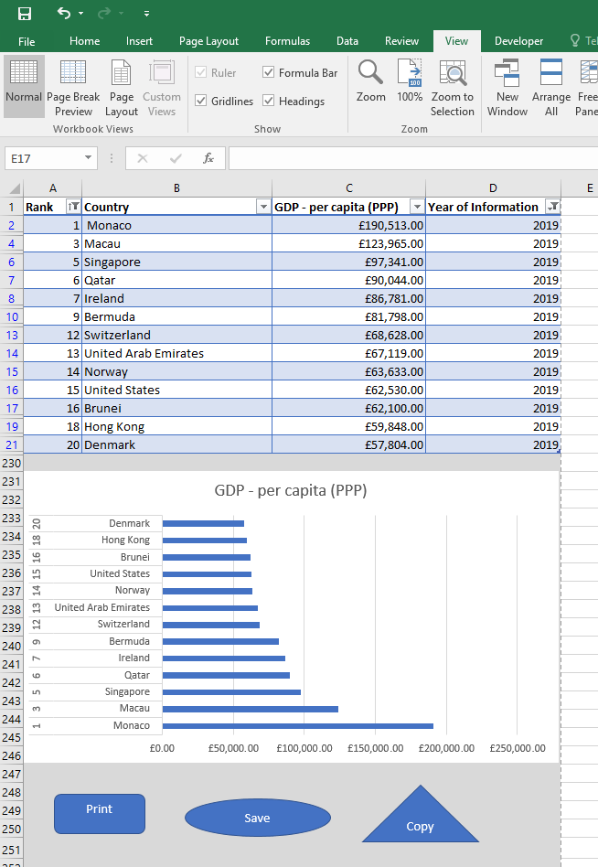

Figure Screenshot of created macros

### Using the copy macro, copy sheet and save in new word document keeping formatting

#### Add title to word page

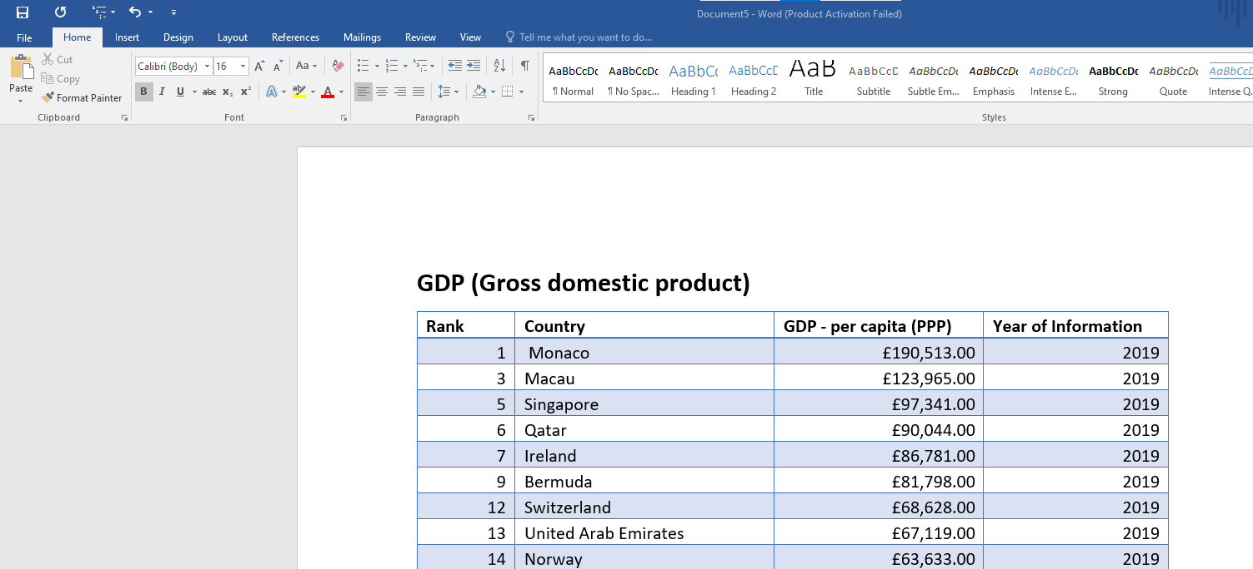

Figure Diagram of created Word document from excel workbook after copying with copy macro

#### Save work in word as ‘Word Gross domestic product’

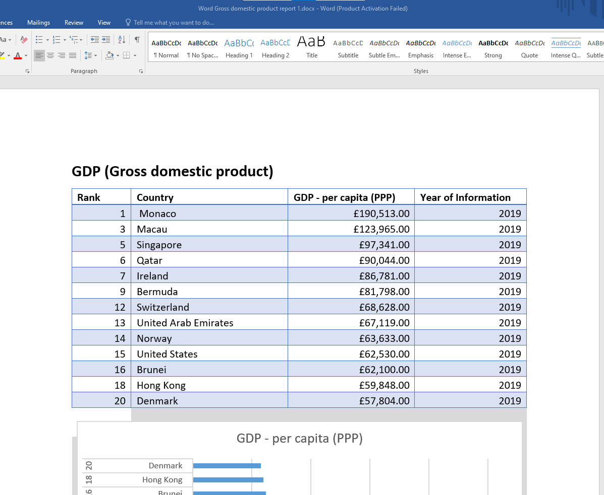

Figure Figure of saved Word document

#### Add header and footer to excel table

##### In header, add name and GLA DATA 1

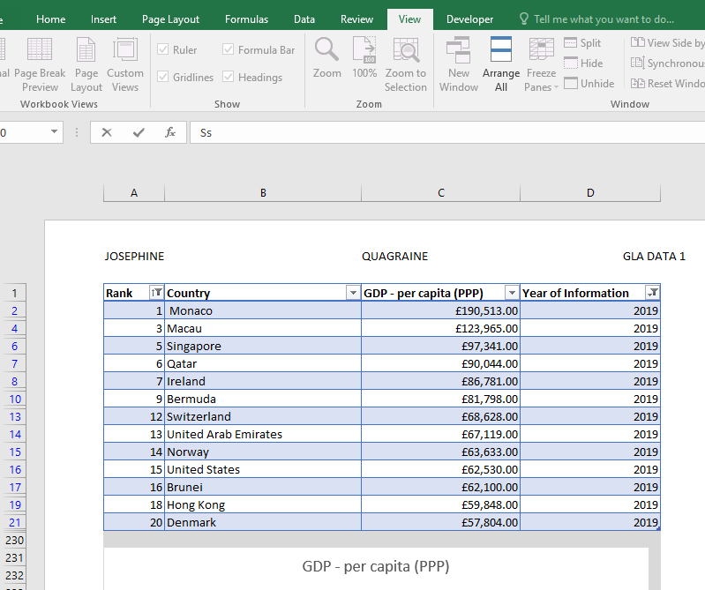

Figure Screenshot showing addition of header to excel table

##### In footer, add date, assignment 1 and data visualisation

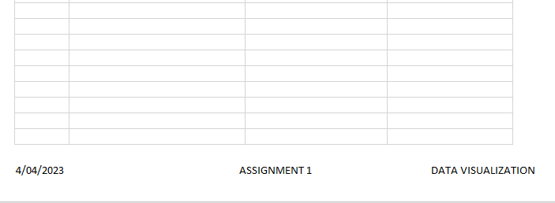

Figure Screenshot showing addition of footer to excel table

#### Return to normal view

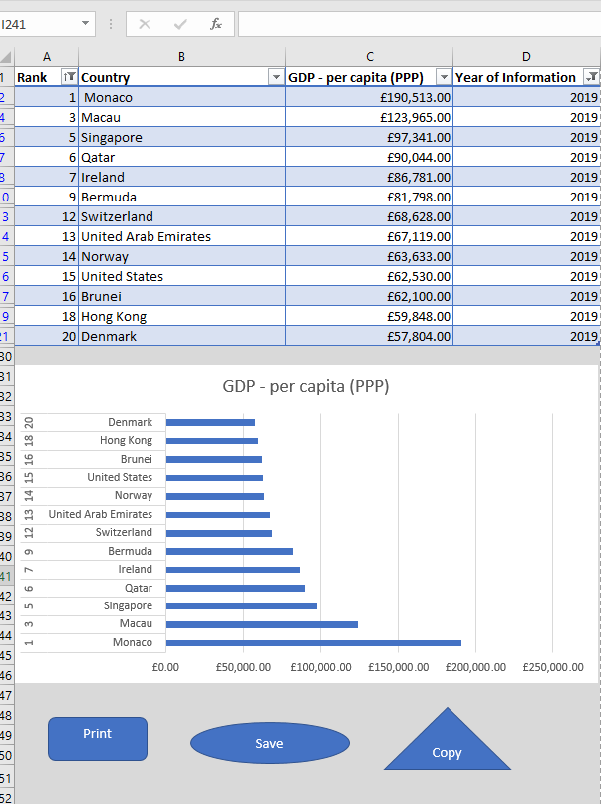

Figure Figure showing normal view

#### Save workbook as ‘Excel Gross domestic product report 1’

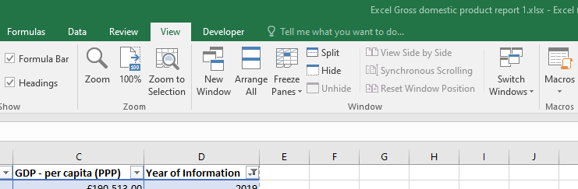

Figure Figure showing workbook saved as excel gross domestic product report 1

## Tableau

Dashboard generated after publishing on Tableau public

<https://public.tableau.com/app/profile/josephine1158/viz/Top20analysisusingWealthofNationsdata/Dashboard1?publish=yes>

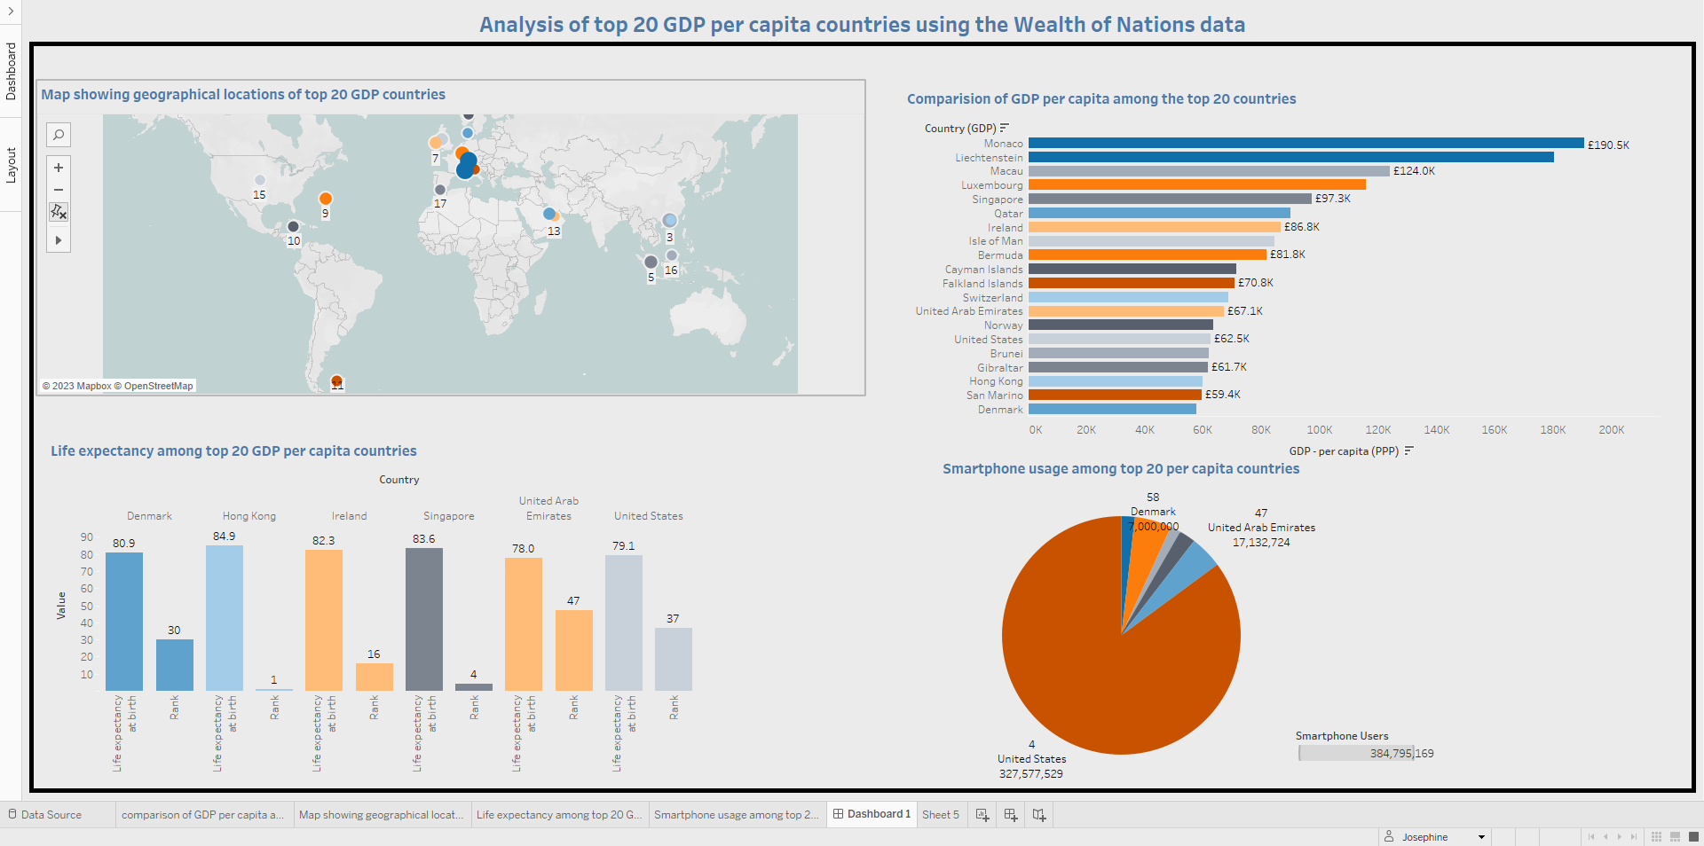

Figure Diagram of generated Tableau dashboard

## Reflective of assignment

Had assignment given on the 28th of March which was the 5th week since commencing the Data technician bootcamp. This assignment incorporated Microsoft Excel and Tableau which we had covered in JustIT bootcamp. The technical tutorial times were used to present the task to the cohort group and also assign us into groups if we wanted to work in groups. A technical trainer was present for the first day. On the second day, there was a slight confusion as there was no technical trainer till after lunch break. We were able to set up a call ourselves after which we brainstormed to solve the task at hand. Due to the fact that there was no tutor, some people left to try to solve it on their own. As such, there were only a few present during the afternoon when the tutor showed up and lead us through some of the tasks we found to be challenging.

I was anticipating the assignment week though a part of me was also nervous as I pondered if I had learnt enough to tackle the assignments. The second day was very frustrating as we were left in a lurch for most of the day. We did not know when the assignment would be due which compounded the problem. In retrospect, though it proved to be stressful at the end, the beginning was quite relaxing and more of another learning experience. Working with my group, I got to know them more and learnt from them as well. Though the second day started badly, we ended up meeting a tutor who guided us quite well. With regards to the Tableau dashboard, I attempted it about 3 times as I wanted it to tell a story. I finally came up with a plan to use the top 20 GDP per capita countries. This gave my dashboard a story that could be connected from an otherwise seemingly unrelated data. This work took me almost the whole week to complete as I spent time learning while attempting the assignment. I had a bit of a challenge a day before submitting to the student portal as I lost some of my work for Excel and had to redo my Tableau when I mistakenly shut down my computer without saving part of my Excel work or publishing my Tableau dashboard. However, as I had saved a screenshot of my Tableau dashboard and made some notes, I was able to regenerate my report to submit into the student portal on time.

On reflection, when given another assignment, I would prefer to finish it early so I can have more time to study other areas of interest. In conclusion, it has been fulfilling to be able to handle the task adequately. It has shown me that I have what it takes to master the tools we have learnt if I put in the time and dedication to study more and make use of the resources given me so far.